Senior Design

Autonomous Subway Inspection Vehicle

Omar Aziz, Noah Bolzoni, Brandon Castro, Anthony Lucero, Sean Maggio, Marcin Wisniowski



Phase 4 Documentation

Refining Design & Prototyping

Table of Contents

**Project Overview** **2**

**Engineering Analysis & Design** **2**

**Functional Diagrams** **10**

**Alpha Prototype Design and Analysis** **14**

**Beta Prototype Design** **18**

**Phase III Comments** **23**

**Project Plan** **27**

**References** **31**

## 

## Project Overview

The New York City subway is the busiest metro service in the United States. Annual subway ridership in New York City surpassed 1.68 billion in 2018 and daily passengers exceed 5.6 million[1]. Therefore, each issue found on the subway track inevitably leads to the inconvenience and delay of millions of Americans living in New York City. Even with the current advancements in technology and automation, many railway track inspections are conducted regularly by human inspectors. In order to satisfy current regulations prescribed by the Federal Railroad Administration, a mainline track is usually required to undergo a weekly inspection and a geometry car inspection is not considered acceptable for meeting this required inspection frequency[2]. It becomes apparent, therefore, that inspectors are in high demand and yet low in availability.

The Autonomous Subway Inspection Vehicle (subsequently referred to as the ASIV) looks to increase the productivity of subway inspections by uncovering and flagging warnings for track defects early, in order to concentrate a subway inspector’s efforts into distinct geographic areas of focus. While the current regulations may restrict the creation of a fully autonomous system, the project, regardless, adds value by creating an autonomous and live asset management of the subway track. When regulations change in the future, the system can be used to provide stronger analysis for proactive operational investments and scheduling of site-technicians and inspectors for daily maintenance.

## Engineering Analysis & Design

**Propulsion**

Building on the calculations and findings from the previous phases, revisions were performed via analysis and design provisions. One of the primary revisions was that of how the electric motors would be chosen and verified for the purpose of driving the vehicle. Previous methods focused primarily on examining how the motors handled under a constant velocity as would likely be the case during normal data collection operations. However, it is important to consider a motor’s performance when it is subject to its highest power draw. Theoretically, this would occur when the vehicle starts accelerating from rest on an ascending grade or slope. In this case, the sum of the forces can be written as follows:

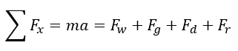

Where the forces are,

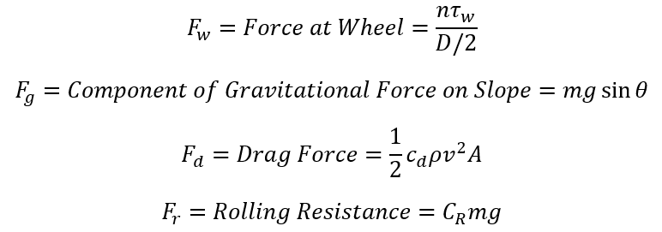

The force at the wheel results from the output torque from the motor (in this case with *n* denoting the number of powered axles) over the radius of the driven wheel. A component of the vehicle’s weight contributes to the forces when oriented downhill or uphill. The drag force considers the shape, frontal area, density of air, and the speed of the vehicle. Finally, rolling resistance can be approximated as a coefficient of resistance (dependent on the material properties of the wheel and rail) multiplied by the vehicle weight.

When the vehicle is at rest and starts to accelerate uphill, the drag force can be eliminated as the velocity is zero. The output torque can be derived as follows,

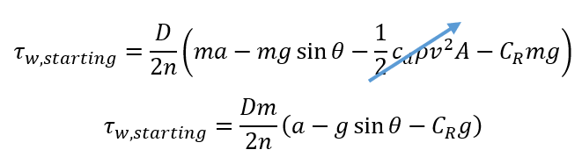

Thus, one could derive the amount of torque required to move the vehicle given a target acceleration.

It is also useful to convert this torque value to an input current in amps as logic dictates that a motor will draw the most current when starting up. Finding this value would be necessary to verify that the batteries, controllers, and motors themselves can withstand the given load since failure to do so can lead to damaged electrical components. Current can be calculated by using the motor torque constant which when calculated in S.I. units, is equivalent to the motor voltage constant. Since clear values of rated voltage and no load speeds are given in this case, the constant is found using said values.

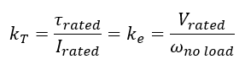

Thus, to find current, the following relationship is utilized,

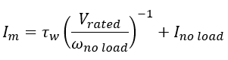

To demonstrate this relationship, specified values were inputted into the equations to yield starting values of torque and current for the alpha and beta prototype dc motors.

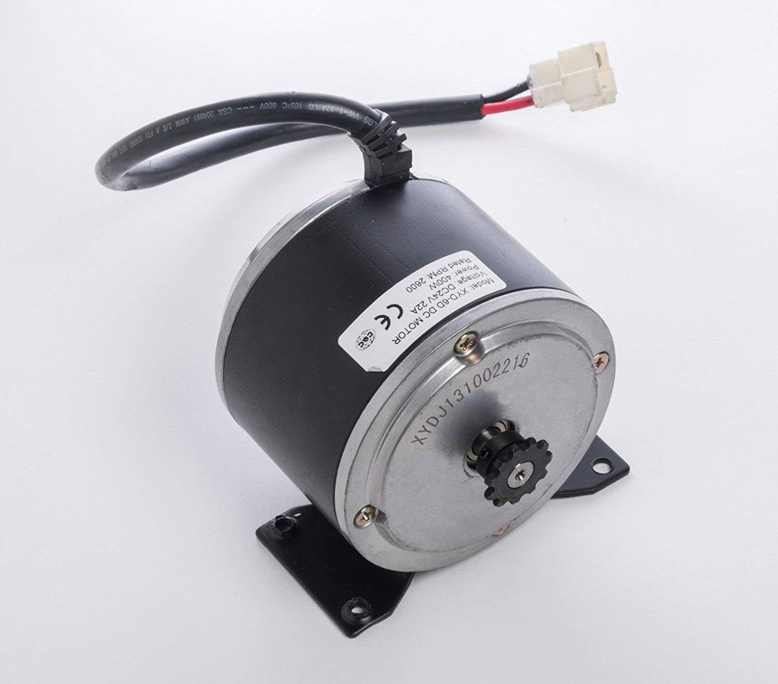

*Figure 1. 400 Watt Single Motor for Alpha Prototype.*

The alpha prototype would consist of a single motor design driving a single axle with two wheels via a chain. A 400 watt scooter motor was repurposed for this role. This motor had the following relevant specifications,

Table 1: Alpha Prototype Motor Specifications

|  |  |
| --- | --- |
| **Specification** | **Value** |
| Rated Voltage | 24 V |
| No Load Speed | 2600 rpm |
| Rated Torque | 0.93 N-m |
| No Load Current | 2.0 A |
| Max Rated Current | 22 A |

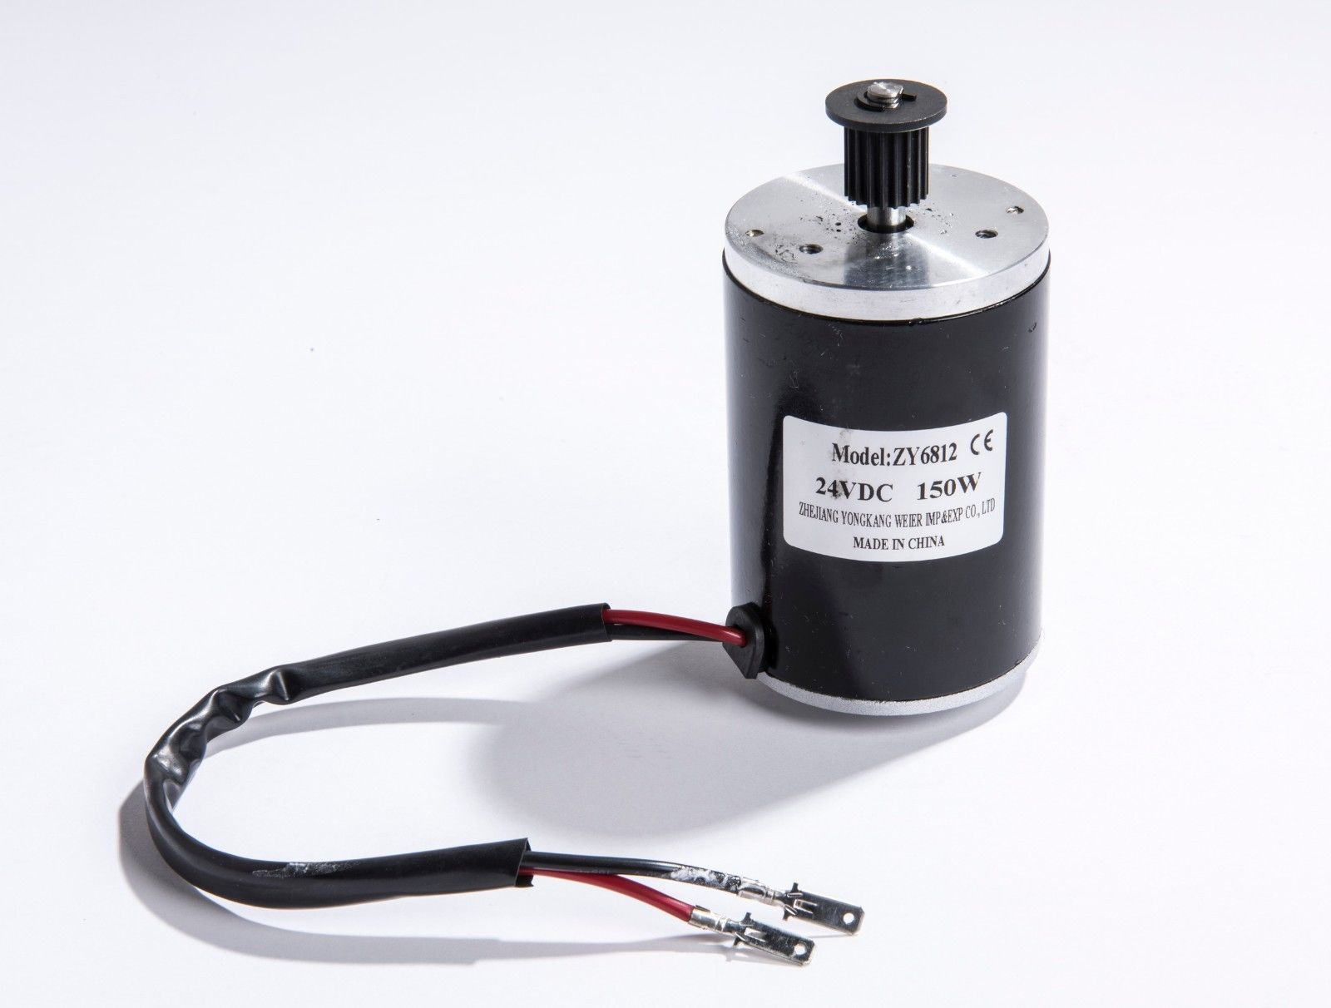

*Figure 2. One of Two 150 Watt Motors for Beta Prototype.*

The beta prototype would consist of two motors driving two independent wheels directly. The motors would be rated at 150 watts each. The desired motors would display the following characteristics.

Table 2: Beta Prototype Motor Specifications

|  |  |
| --- | --- |
| **Specification** | **Value** |
| Rated Voltage | 24 V |
| No Load Speed | 3500 rpm |
| Rated Torque | 0.52 N-m |
| No Load Current | 0.8 A |
| Max Rated Current | 9.6 A |

For the purpose of this analysis, the following values were inputted for the vehicle chassis and mechanical components.

Table 3: Shared Prototype Vehicle Specifications

|  |  |  |
| --- | --- | --- |
| **Specification** | **Value** | **Comment** |
| Total Mass | 23 kg | Includes wheels |
| Wheel Diameter | 32 cm | Nominal Value |
| Projected Frontal Area | 0.3 m2 |  |
| Drag Coefficient | 1.0 | Conservative Value |
| Rolling Resistance Coefficient | 0.002 | Approximation for Wood Wheel on Steel Rails |

The final component of inputs for this analysis was the target values of velocity, acceleration, and incline for each prototype.

Table 4: Desired Kinematic Targets

|  |  |  |
| --- | --- | --- |
| **Target** | **Alpha Prototype** | **Beta Prototype** |
| Normal Operating Velocity | 5 mph | 10 mph |
| Normal Acceleration | 0.2 m/s2 | 0.2 m/s2 |
| Reduced Velocity | 2.5 mph | 5 mph |
| Reduced Acceleration | 0.0667 m/s2 | 0.0667 m/s2 |
| Gradient | 20 mm/m | 20 mm/m |

Notice that both prototypes possess a “reduced” velocity and acceleration target. This target would be utilized primarily when climbing up an ascending grade. The purpose of this reduced target is to prevent the need for an excessive amount of torque, which could potentially result in generating a dangerous amount of electrical current passing through the motors and controllers. Additionally, as the purpose of both prototypes is for proof of concept, a moderate gradient value was chosen to demonstrate that the targets are achievable, and with the assistance of a more robust motor, they can be exceeded.

With all of the needed inputs tabulated, calculations could be performed using the equations outlined at the start of this section. As an example, the starting torque and current for the beta prototype motors on a 20 mm/m ascending grade are derived in the following steps.

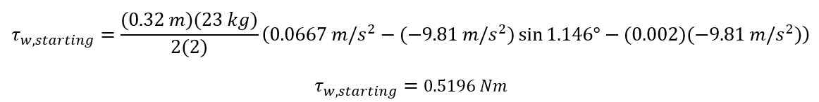

Notice that a value of two is used for *n* since the two motors power two independent wheels on the beta prototype. Also, notice that a value of 1.146° was used for 𝜃 as this is the equivalent angle of incline to a gradient of 20 millimeters for every meter (through use of arctangent). In this worse case testing scenario for the beta prototype, the load torque is almost identical to the rated torque of the motor at 0.52 Nm. Under normal testing conditions, this value will rarely be reached. Next the current could be calculated using the motor constants.

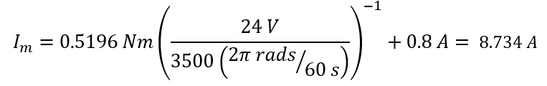

In this case, the motor’s design current is not exceeded and thus the target acceleration is achievable. Also, of note is the fact that this value falls well below 70 amp short discharge current limit specified for the 7 Ah batteries that will be utilized for both prototypes.

The remaining calculated values for torque and current can be found in the table below for all cases for both prototypes.

Table 5: Resulting Torques and Currents

|  |  |  |
| --- | --- | --- |
| **Target** | **Alpha Prototype** | **Beta Prototype** |
| Starting Torque Uphill | 1.039 Nm | 0.5196 Nm |
| Starting Torque on Level Track | 0.8082 Nm | 0.4041 Nm |
| Torque Uphill at Constant Speed | 0.8300 Nm | 0.4690 Nm |
| Torque on Level Track at Constant Speed | 0.2161 Nm | 0.3239 Nm |
| Starting Current Uphill | 13.79 A | 8.734 A |
| Starting Current on Level Track | 11.17 A | 6.971 A |
| Current at Constant Speed | 11.42 A | 7.962 A |
| Current on Level Track at Constant Speed | 4.451 A | 5.746 A |

Comparing these values with the rated torques and max currents for the respective motors of each prototype shows that the limits are not exceeded, and thus the targets can be achieved.

It is also helpful to calculate the theoretical battery life for both prototypes before the next charge if the operating routine is approximated as having the constant target speed over level track for the duration of the run. In this case, the battery life is derived simply by dividing the battery capacity (in this case of 7 Amp hours for both prototypes) by the operating current. Note that in both designs, two 7 Ah batteries will be connected in series to double the operating voltage to 24 V while keeping the overall capacity to 7 Ah. Thus, the battery life for both prototypes are summarized as follows.

Table 6: Resulting Torques and Currents

|  |  |  |
| --- | --- | --- |
| **Target** | **Alpha Prototype** | **Beta Prototype** |
| Battery Life with 7 Ah Battery Pack | 1.573 hours | 1.218 hours |
| Equivalent Distance Traveled at Constant Speed | 7.863 miles  (at 5 mph) | 12.18 miles  (at 10 mph) |

Electrical Design of Robot:

The electrical design is broken into three parts: actuators, data collection and controls. This section discusses data collection and controls. Actuators are discussed in the mechanical section.

**Measurement:**

The beta prototype will measure two elements of track geometry: gage and crosslevel. More measurements can be found in The United States Department of Transportation’s Track Safety Standards Compliance Manual (2002)[9]. The manual discusses the Federal Rail Administration’s “Automated Track Inspection Program” (ATIP), which uses cars equipped with sensors to measure rail geometry, and explains which measurements they collect. There is also another section which discusses which parameters a track inspector on foot should measure. Of these measurements and values, the geometry measurements are considered in a basic sense below:

Gage: width between inner rails, ⅝ inch below running surface (top of rail)

Crosslevel/superelevation: difference in height between rails

Alinement: how much the rail bend out of alignment horizontally

Profile: the vertical equivalent of alinement

Runoff: Change in elevation down a ramp (related to profile)

Curvature: defined using mid ordinate offset at the middle of a chord

The ASIV beta prototype will measure gage and crosslevel. Focusing on two measurements ensures a more quality prototype. These two measurements were also recurring measurements in other track geometry projects during our early research. One report stated the entire state of a track could be recorded using gage, an IMU angle measurement (used for crosslevel in our model), and geometrics[7]. During a phone interview with an MTA operations employee, we asked “What are the most important measurements to consider?” The reply was “Well, you definitely want to check gage.” He could not day more for security reasons. These two measurements also are more accessible to reading, since others rely on 62 ft or 31 ft chords.

**Gauge**

The gauge will be measured using two optoNCDT ILD 1402-200 laser distance sensors donated by Micro Epsilon. The distance from each sensor to the inner rails of the tracks can be added to the distance between the sensors to get a gauge reading.

The sensors have the following characteristics:

* Measuring range: 60 - 260 mm
* IP 67 rated
* Linearity: 40 - 360 µm
* Operation Temperature: 0 - 50 ℃
* Temp Stability: 0.08%FSO/ ℃
* Vibration Tolerance: 15g / (10Hz - 1kHz)
* Shock Tolerance: 15g / 6ms

They would likely be suitable for summer, spring, and fall operation.

Sources of error include angle of the Micro-Epsilon sensors to the rails. Ideally they would be placed perpendicularly, but to avoid obstacles, they will need to be placed at an angle. The error based on angle is shown below in Figure 3:

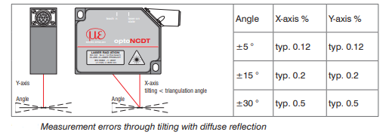

*Figure 3: Error at Angles*

The error is minimal if placed at a low angle.

**Crosslevel**

Crosslevel will be measured using an IMU (minIMU v5 from Pololu). The IMU will provide an angle, and using the gage at the position of the measured angle, trigonometry can be used to find the crosslevel. This is shown in Figure 4

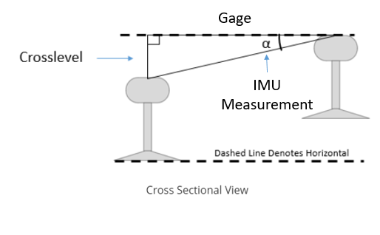

*Figure 4: Crosslevel Calculation*

**Data Collection:**

For our prototype, data will be collected using a DataLogger shield for Arduino from Adafruit. It will be written in CSV format to be analyzed in Excel.

**Control:**

Overall control will be done using an Arduino Mega. It is possible we may put a data logging loop on a separate Arduino, which can then be called on by and communicate with the Mega.

## Functional Diagrams

In order to effectively run the robot, an electrical circuit diagram was constructed to help visualize connections within the robot. The following is a depiction of the beta or final prototype system:

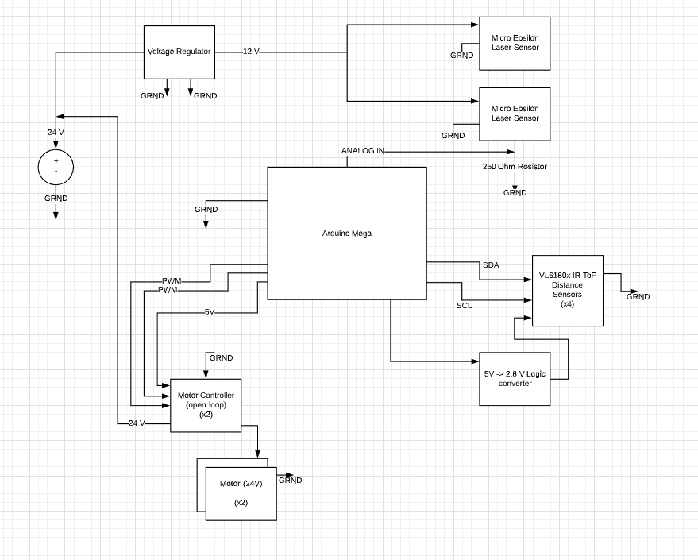

*Figure 5. Electrical Circuit Diagram*

The above electrical diagram specifies the necessary connections in order to have the distance sensors and the motors to work as desired. A voltage regulator helps step down the voltage to desired values and PWM control will be implemented on the motors in order to control movement.

Furthermore, the following diagrams will connect other important electrical architecture found in our design including the data logger to allow for writing to an SD card in CSV format.

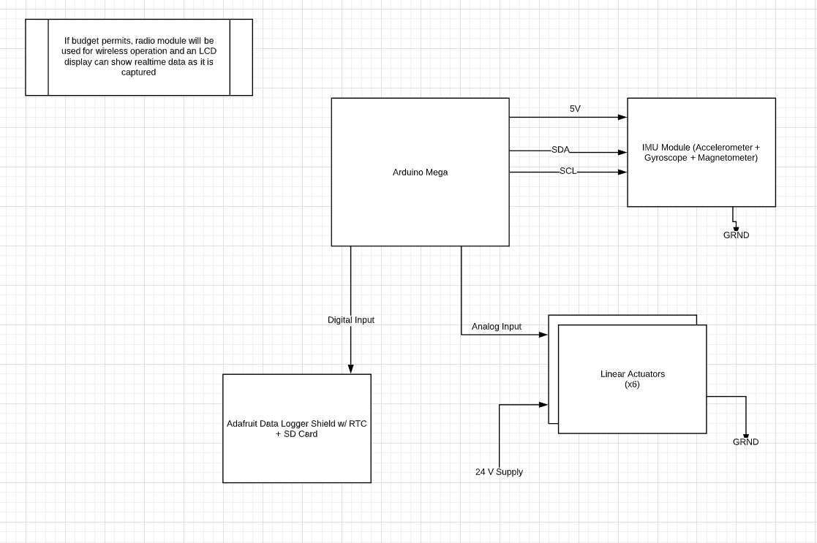

*Figure 6. Electrical Connections Diagram*

After laying out the connections, it is also relevant to show an operational diagram of the beta prototypes’ expected functionalities. This has been updated from previous versions to depict a more realistic and viable end result within the given time frame and budget.

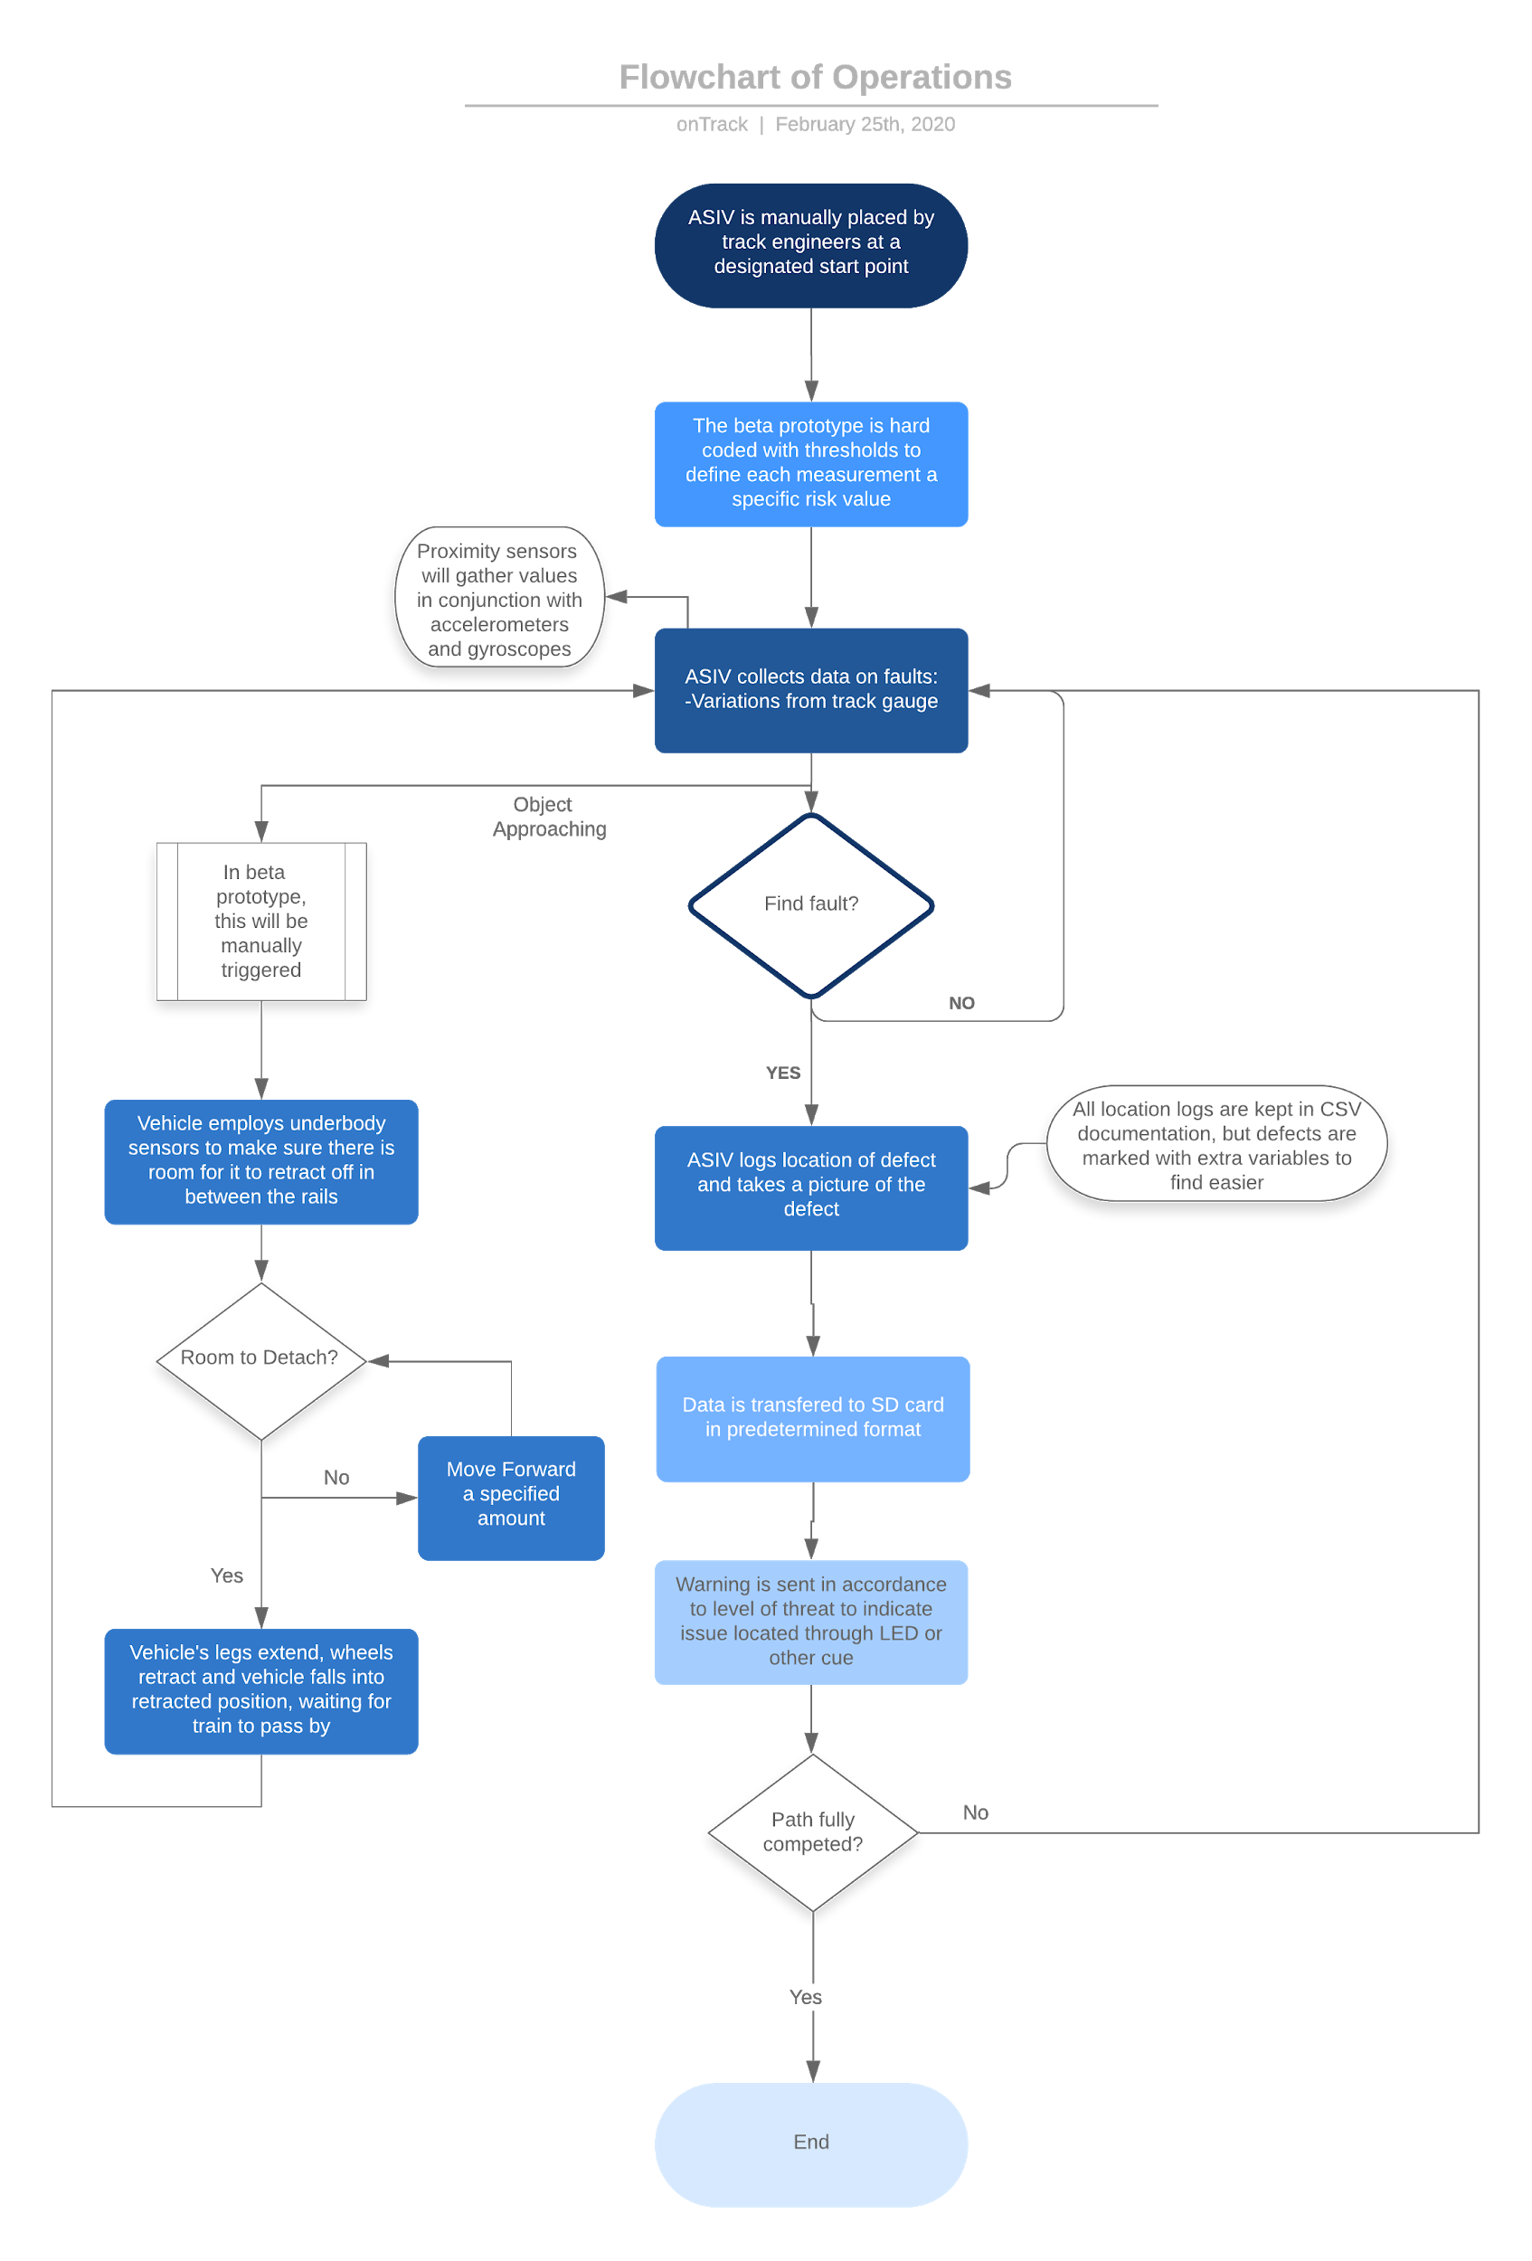

*Figure 7. Flowchart of Operations*

## Alpha Prototype Design and Analysis

In our current state, the alpha prototype consists of two separate systems to test functionality and viability. The first system that was built was the previously documented minimum viable product for the mechanical system, consisting of wooden wheels on two separate axles, connecting to a motor and battery system to test for motion. The sensor subsystem was left off of the alpha prototype for now, as separate team members were working on both projects.

Mechanical Design Alpha Subsystem:

While thorough weight and motor power calculations were constructed, it was necessary to build a testing platform in order to best understand the dynamics of the vehicle. The alpha prototype is designed to represent the final prototype in its “extended” mode, which is just traveling on a straight track. This means that a wheel retraction mechanism was not needed at this stage of the prototyping, but the both vehicles will act the same if tested on a straight track.

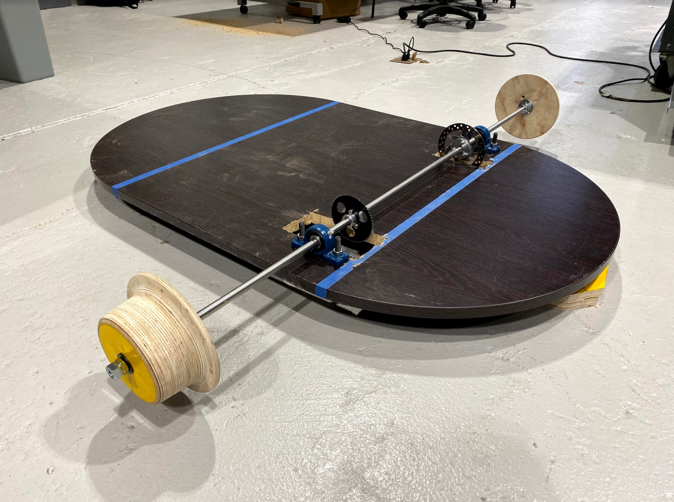

*Figure 8. Alpha Prototype With Front Axle Mounted*

Many days over several weeks were spent in the machine shop creating the custom parts for the design and the last week was used to put the parts together. Unfortunately, due to constant usage of the CNC milling machines by the Baja team, significant delays in machining the wheels were encountered, leaving the team a few days behind schedule on testing the values for the designed alpha prototype and will use the next few days to confirm data follows the technical analysis that was previously conducted.

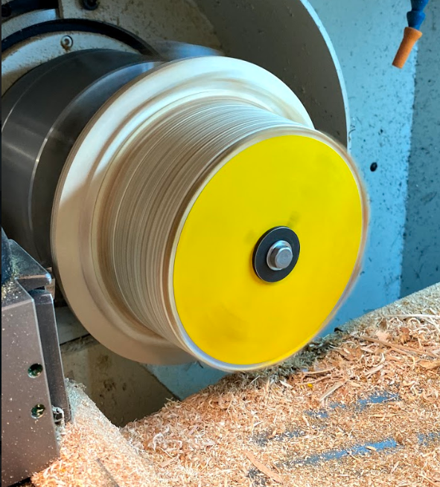

*Figure 9. Milling of Custom Wheels for ASIV*

Laser Sensor Design Alpha Subsystem:

The group also worked on making an alpha proof of concept for the sensor system in order to understand how it gathers data and made it available in a CSV file format for saving and editing.

The sensor circuit diagram was built as seen below and readings were taken in order to measure voltage. As the distance from the target changed, the sensor outputs displayed different values between 0 and 1023 in the output reading.

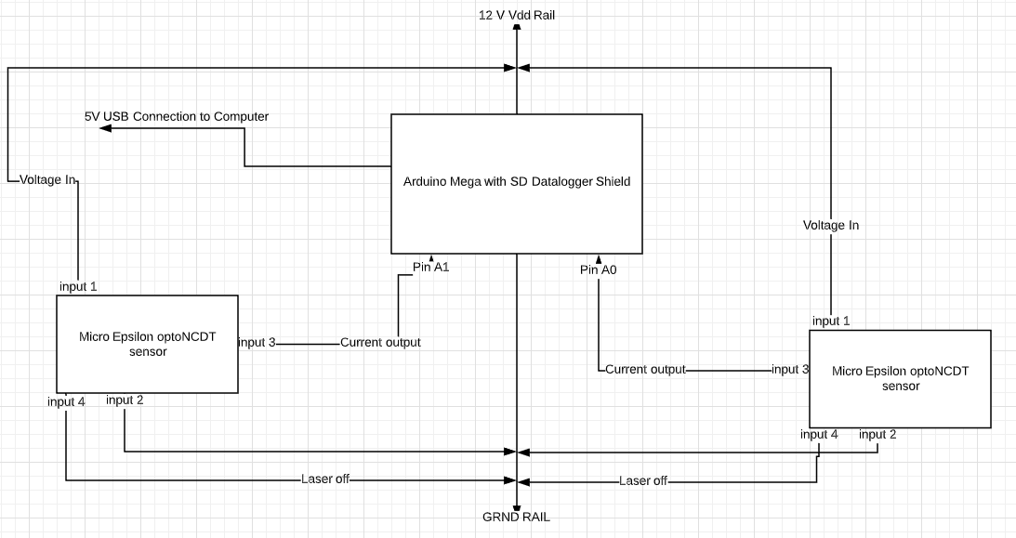

*Figure 10. Sensor Readings Circuit Diagram*

Later in the process, the team will look towards combining the readings from both sensors to concatenate into one track gauge reading. Furthermore, the team is working on incorporating an IMU module in order to track tilting and elevation differences which may result in changes in the sensor output, but can be corrected before written into the CSV file. After setting up the system, the following diagrams show that the team was able to display the data on a serial plotter incorporated with arduino as well as transfer that same data into a CSV file for asset management.

## 

*Figure 11. CSV Files automatically created within SD Card to save data*

## 

*Figure 12. Serial Output of Left and Right Sensor Readings in Arduino Plotter*

## 

*Figure 13. Output saved and displayed within Excel as CSV Format*

## Beta Prototype Design

The choice of creating a fixed axle vehicle for the alpha prototype means that the beta will have to be a new vehicle and cannot be built on the alpha (due to different drive system and wheel retraction). However, this choice was necessary due to the uncertainty in vehicle dynamics on a track, which the alpha vehicle will provide valuable test data to further help inform the beta design. Additionally, many of the components from the alpha, especially the axles and wheels along with other machined parts, will be reused, saving many hours of machining time. The axles will be reused by cutting them down to a shorter length, keeping the threads and keyways intact. The wheels will simply be transferred to the beta with no additional modifications. Some retaining ring grooves and new keyways for belt drive pulleys may need to be added to the axles, but this will not account for more than a few hours of machining time. The large majority of the beta prototype will involve cutting aluminum square tubing, steel sheet metal, and plywood sheets to simple shapes for the construction of the frame and chassis of the vehicle. The transition from the alpha vehicle to the beta vehicle has been carefully thought through with an emphasis on reusability and simplicity.

Many iterations of the beta prototype have been made and revised over the past few months. Until recently, the beta prototype was planned to have two identical aluminum truss structures faced with steel sheet gusset plates, with each structure holding one front and one back wheel and one motor. The sensors would be placed on the long straight section of tube between the wheels, keeping the sensors fixed to the plane consisting of the two points of contact of the two wheels, which would also keep them fixed relative to the track (assuming a straight section of track). Two weight bearing sections of aluminum tubing would protrude from the truss structure towards the middle of the vehicle, and these would be placed in slots where they could slide freely while still supporting the weight of the vehicle. One linear actuator per structure would be attached to the middle of the structure, and the actuators would push or pull on this point to extend and retract the wheel base structures.

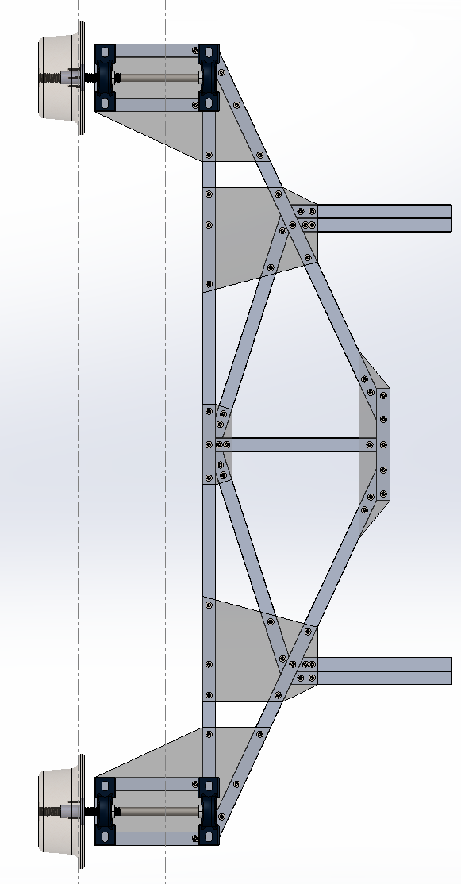

*Figure 14. Original Beta Wheel Base Design*

There were many issues with this design that led to a recent pivot in the design of the vehicle. First of all, this direct method of retraction and extension limits the range of motion to the stroke of the linear actuators. This means the vehicle would get only six inches of travel on each side. Larger actuators are not only more expensive, but have much slower travel rates, and do not fit in the vehicle if placed back to back. Secondly, the weight bearing beams cannot retract the required range of motion. Since the vehicle is symmetrical, the beams collide into each other after traveling a distance of less than six inches. Shorter beams were considered, however, this still did not provide enough travel, and also now concentrated the weight of the vehicle on a much smaller section of tubing. Additionally, the amount of aluminum and hardware needed such as rollers for the slots would be very costly relative to the remaining budget.

With these factors considered, a new design was created that solves many of the problems. The front and back halves of the wheel base were split and the truss design was largely simplified. The wheel retraction mechanism now functions by rotating four wheel wheel bases about a large pin in a brass sleeve bearing.

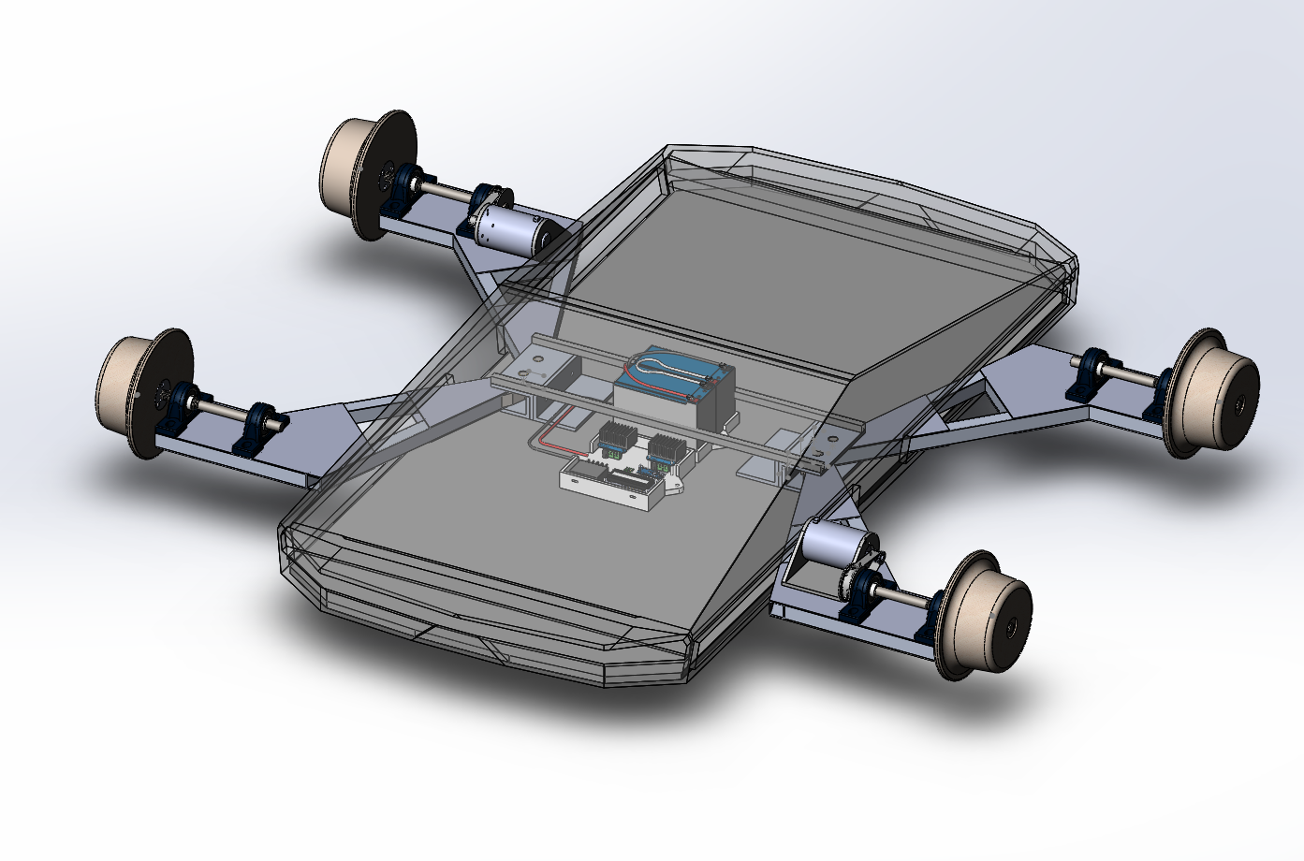

*Figure 15. Beta Prototype Isometric View*

There will still be two linear actuators, with one for each side of the vehicle, but now that the wheel bases are four individual subassemblies, a mechanism was needed to duplicate the motion from one linear actuator on to two wheel bases. Between the pinned connections of the wheel bases are two identical gears attached to the end of the aluminum tubing from the wheel bases. These gears connect the two wheel bases on one side together. The linear actuator is attached to one wheel base from a further point on the side.

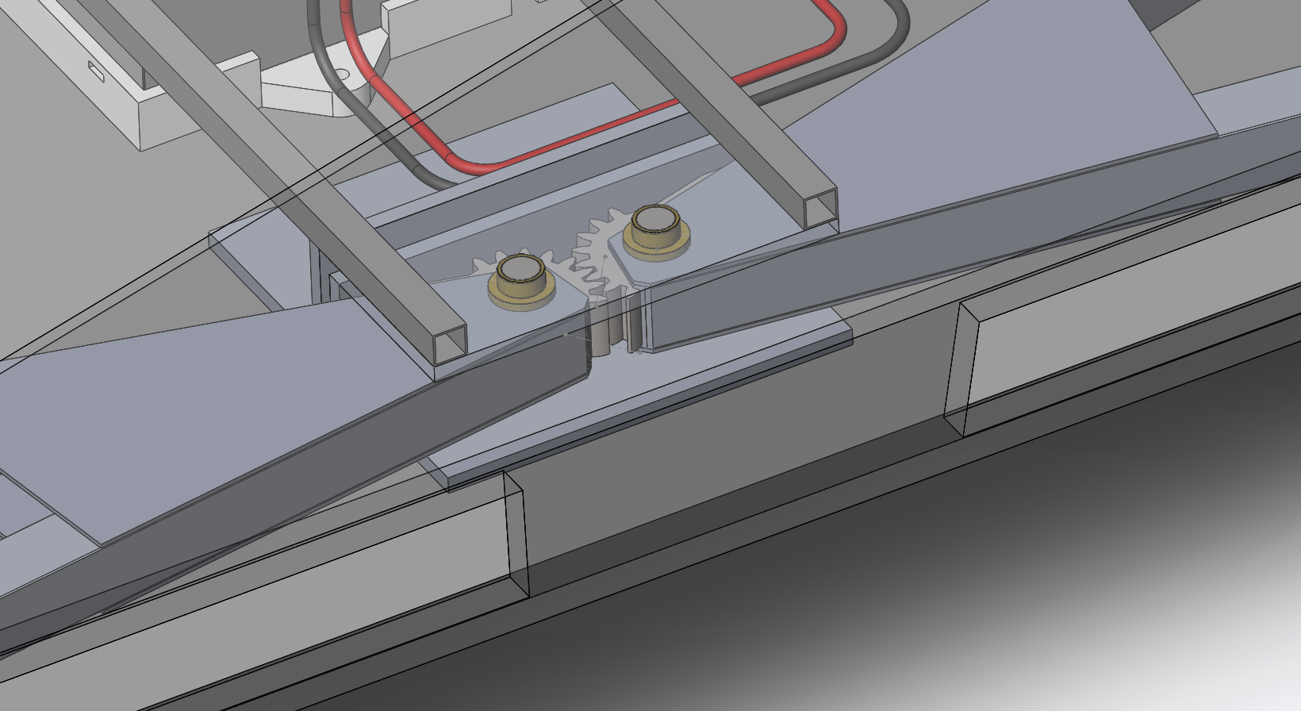

*Figure 16. Close up of gears for retraction mechanism*

The actuator has pinned connections on both ends, allowing it to rotate as it extends or retracts. This solution increases the travel by up to 50%, simply through rotational motion rather than linear. It also allows for further tweaking of the attachment points to optimize travel, and has room for longer stroke or larger actuators that could be used in the production model. Instead of complex slots and rollers, the wheel bases are mounted on aluminum angle stock, which is attached to the chassis.

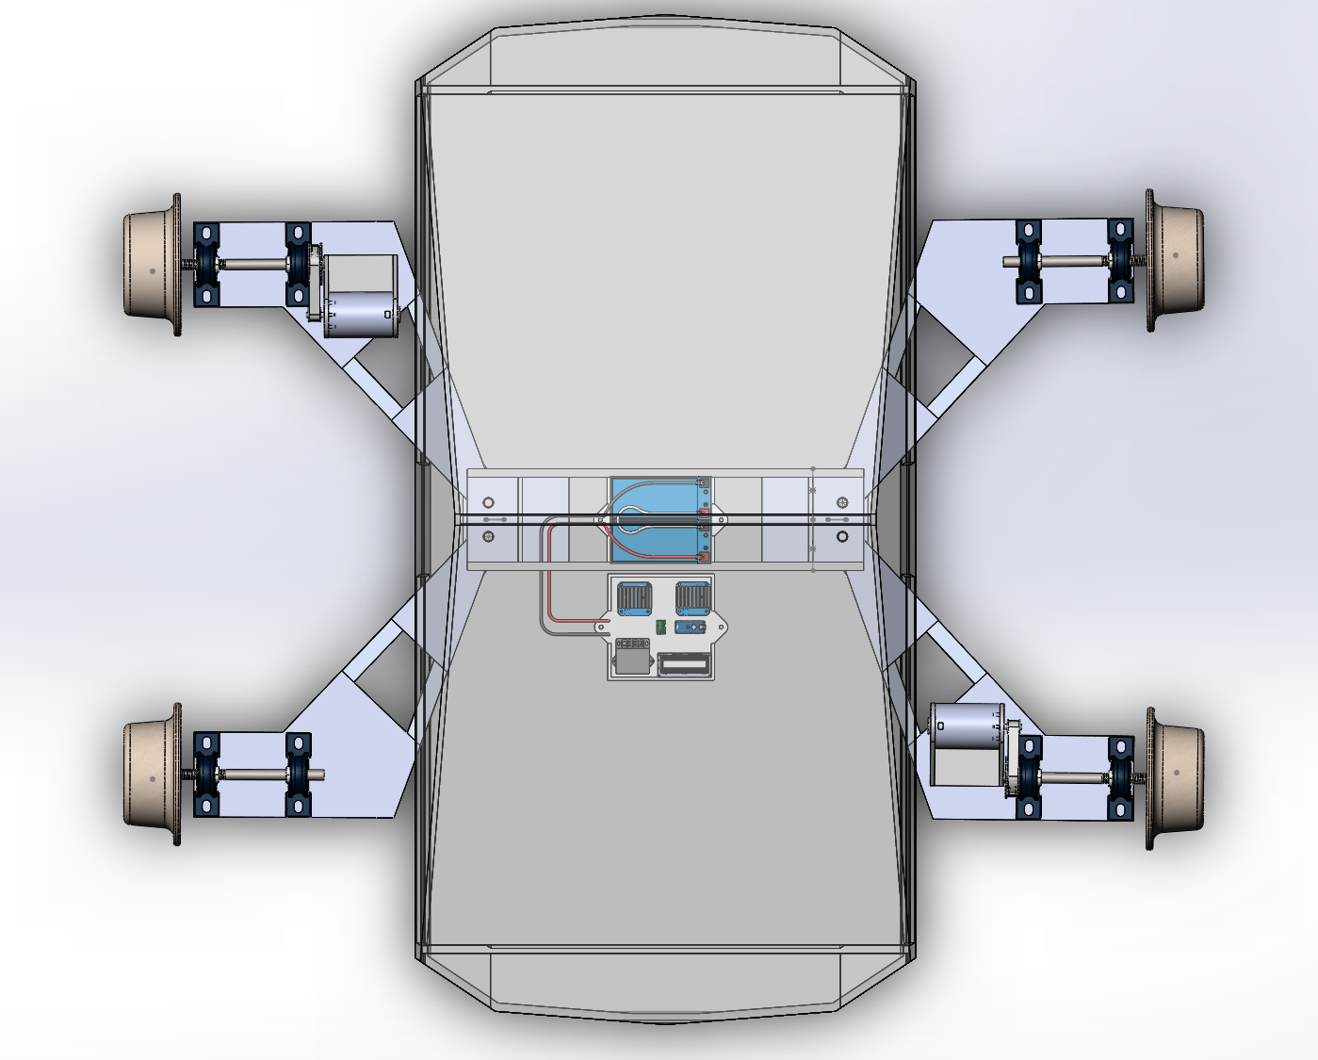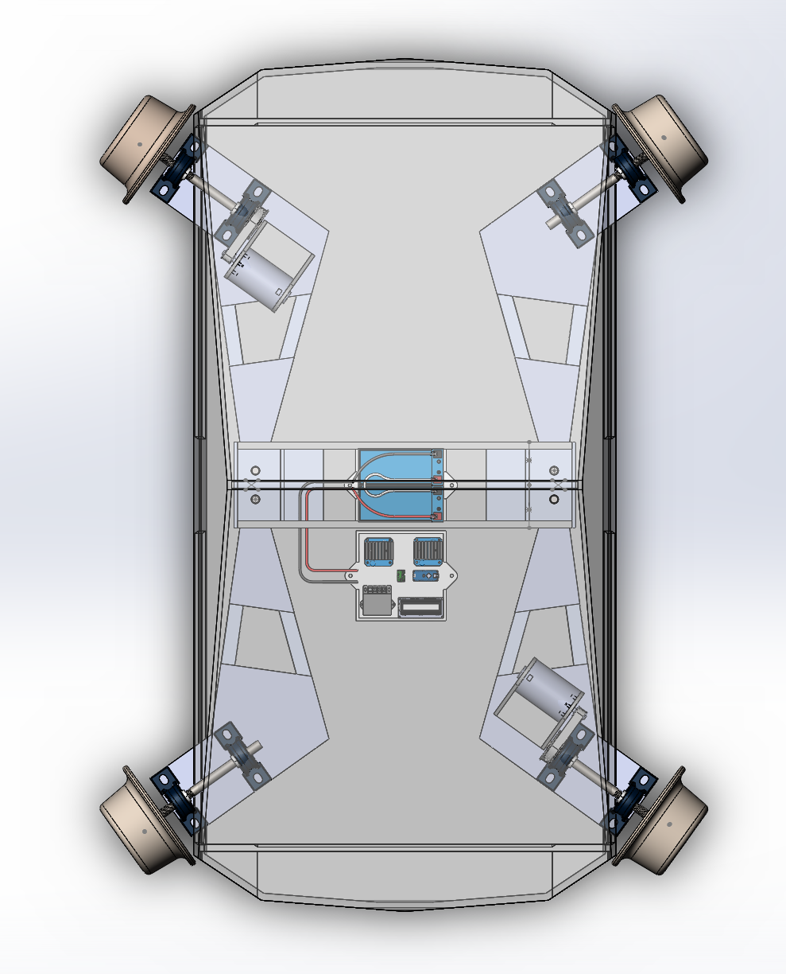

*Figure 17. Extended vs Retracted*

**Electrical:**

**Beta Functionality**:

The final prototype is expected to have the following features:

1. Master on/off
2. Speed and direction control via potentiometer knob
3. Data collection on/off switch
4. Emergency off button
5. Gage and IMU angle collections and write to SD
6. Retraction mechanism triggered upon button press

The control buttons and switches will be attached first directly to the vehicle using long connections, but we would prefer to use a wireless HC-12 radio device to control the robot wirelessly with another arduino reading and sending inputs.

The overall approach to creating a successful design is to do each function in pieces. For example, during the Alpha prototype construction, writing to the SD card and collecting measurements from the laser sensors was done separately before combining the features. This idea of massing a collection of subparts will make the process of complete system architecture and coding clearer and more flexible. The most important item to consider in the next phase is how to safely conduct measurement readings on a moving vehicle. This means there must be a way to stop a run away car remotely. Below are a few ideas. Combinations will be implemented:

1. Three industrial normally closed cutoff buttons on vehicle. One on front, one on back for shutting off when hitting obstacles, and one on top for close by personnel to operate (last resort measures)
2. “Run”bit in code. If true, vehicle can run. If false (operated via button on console) motors turn off
3. “Run” bit dependent on physical connection. Operator holds object connected to microcontroller input. Robot only runs if input reads high. If robot begins to run away, object yanks connection and “run” bit goes low, stopping vehicle (in essence, a physical “key” must be inserted to run)
4. Physical key principle which connects main battery to motors (may not be implementable safely)

**Extra Functionality:**

Recently, it has been realized we may be able to construct a 3D map of the rails in Matlab using only IMU and gage measurements. This idea is being explored further and would be the ultimate goal of the Expo should everything else work first.

## Phase III Comments

*-Pg 4 report pg, / 8 slide -since you are making a proof of concept design, you don't have to burden yourself with high frequency data collection. Be aware of your limitations, and use the data acquisition capacities properly. Too much data can be a problem that you don't need. How much calculating and storage power can you save if you find a good balance between data acquisition frequency and the unit velocity?*

In the alpha prototype distance collection system, the data collected can be scaled down using a delay function. However, if we create a 3D map of the rails in Matlab, we may desire extra points of measurement. They are captured in a CSV, so they do not take up much space in the time we test. With no delay function implemented, the robot was able to capture ~1550 data points within 30 seconds, or 52 data points a second. We believe this can be tested to find the best range while also keeping enough to gain statistical significance.

*-I am not sure what the point of the evasion mechanism is (in your project)...?*

ASIV is a novel approach to track inspection which does not interrupt service. The mechanism makes for a more interesting engineering project which will teach us more mechanical and electrical skills.

It is required for retracting the wheels and allowing trains to pass over the vehicle. No subway system would purchase a vehicle that requires them to stop service on an active track.

This is also a proof of concept which we hope can be integrated with future CBTC (Communication-Based Train Control) to know where trains are in the vicinity and get off the rails within a reasonable amount of time.

*-Report design of the wheel assembly is not the best. Think on how you can improve it. Overall (mechanical) design of the system is under par.*

The wheel design follows a typical rail wheel design. It has a conical shape that allows it to self center on the on the rail, as well as a flange that prevents the wheel from sliding off the track while navigating a curve. The mechanical design focused on in the last presentation was the alpha prototype design. The alpha prototype is a simplified version of the beta design that gives an idea of how the beta design would operate on a straight track. The alpha prototype is only a simplified design to show proof of concept. The beta prototype design is more up to par in terms of mechanical design as it includes the train evasion mechanism and a much more rigid chassis design. The design for the wheel retraction mechanism adds an extra mechanical complexity that the alpha design was lacking.

*-In your opinion what would be the most important conditions to observe while the vehicle is operating (form the measurement side) like vibrations, yaw, uneven rail height etc. Try to address conditions that might affect your measurement process...When this is done design design will have a solid foundation. "*

Vibrations are an important concern and can be reduced with rubber. This may be an excellent shock absorption technique since travel is limited. The reliability of the track geometry measurements would be affected by a suspension system with lots of travel.

*"#9 ""400kHz is sufficient"" - I would say so. This is a crazy high data collection rate. What do you actually need?*

400kHz proves the sensor will not be the limiting factor in data collection rates. The Alpha test used sensors with a data collection rate of 1.5kHz, and this seemed sufficient. It also shows that the Arduino polling rate is sufficient for our needs. We may incorporate multiple measuring settings into our beta prototype design, such as a mode which takes measurements at the press of a button, at set distance intervals, or at set times. This may not require a high data rate, but if we create a 3D matlab model of the rails, more points could be used.

*Distance to rail of 0.5 inch or so does not leave a lot to error if your system moves around. How robust are the sensors? Could you measure the distance mechanically instead?*

0.5 inch was incorrect. The actual FSO of the Micro Epsilon laser distance sensors is 60mm to 260mm. Contact measurement options were considered, but not used since the obstacles present on the inside of the rail are unknown (for instance at junctions where multiple tracks may be intersecting). Laser sensors provide some safety distance, but they DO give some error when turned at an angle to the measuring surface. This error is shown below:



*Figure 18. Error from angles*

As can be seen the error is very low. This is important since the sensor likely cannot be perpendicular to the inner rail surface it measures. It must be at an angle to avoid mid rail obstacles.

These sensors are industrial grade and IP 67 rated. The VL6180x sensors are not industrial grade, but would likely not be used on a production model of the robot.

*#12 why use 3 processors and not just 1 more robust/larger system?*

After further research into the control architecture, the design has changed to include only one larger system for the processors.

*Why travel at 25 mph? How does this interact with data collection rates and so on?*

This value was arbitrary. It seemed good to design a system that worked quickly, but if it must run slower it will. It may affect data collection on something with our beta prototype’s control architecture if the polling loops of the microcontrollers is not quick enough. Then measurements listed as taken at a certain point would really be taken slightly apart from each other. We chose a number that could travel relatively similar speeds to trains, in order to keep it out of the way of incoming and oncoming traffic on the rails.

*#23 What is the vehicle made from? Have you considered the flexibility of the system and how this might cause errors in your measurements?*

Rubber or shock absorbers can reduce travel and vibrations. The sensors will not be affected by the flex of the vehicle since they will be mounted close to the wheels on the most rigid part of the structure.

*How much does the system move sideways on a curve? Does this movement cause the sensors to hit the rails?*

This must still be calculated, but the sensors are certainly far enough away. A basic calculation for overhead twist can be seen in a previous section, and the change in angle relative to the rails around a curve will be calculated in the future if the basic systems of our robot can function.

*Chain tensioning should be considered.*

Chain tensioning will not be needed. The chain is only being used in the alpha and will not be significant in our testing. It is not worth the time or money to invest in a chain tensioner when we will not be using a chain in the final prototype. Considering the scooter that the motor came from did not use a chain tensioner, and could carry an adult human, our project will work well enough for the duration of the alpha testing.

*#32 How are sprockets attached to the axle? This might not be as simple as you assume. Are you using set screws? This is probably a bad idea.*

Although we looked at design tables for set screws and made sure our torsional holding force was exceeded by at least a factor of two, we switched all of our set screws for keyways. One group member had experience with a very similar system where set screws were used for a sprocket and in a much higher torque capacity, which is why set screws were originally considered. However, keyways provided more stability so that the hub with the sprocket would be further locked into place, but this of course increased machining time by a few hours.

*"Due to the conical shape of the wheels, the axle will rise up on one side and lower on the other side on curves. This will affect your reading of the vertical measurements of the rail.*

*Presently the vehicle configuration resembles more of a toy than a research vehicle.*

*Consider a more robust design so it can survive a real subway environment.*

*From the point of vehicle stability, you should consider a larger space between axles.*

*Good progress since last presentation."*

It was mentioned several times that our simple alpha design will never encounter a subway environment. The alpha is an analogue for the beta when it is travelling on a straight track. It will be dynamically similar, but without the extra complexities that come with the beta chassis design. This is the closest yet simplest thing we could build to the beta that serves as a good test bed for testing all of our subsystems instead of just one.

Electrical: The Micro Epsilon sensors are industrial grade and rated at IP 67. To create a strong beta prototype, connections will be soldered and permanent, and sensitive electronics will be encased (possibly in a Faraday cage). The rising of one axle must still be calculated, but we are aware that a basic calculation would be a function of the wheel’s conicity and the curvature of the section of track. On a straight track, the wheels will self center. We are aware of the tilt on a curved track, however, and we are working on mitigating this in our readings. The group is testing with an IMU module in order to be able to collect values of rotation on the chassis which can be used to readjust the vertical measurements. Testing needs to be done, but IMU values can be currently read in degrees of yaw, pitch, and roll.

*“The sensors are too short of a distance range to measure the variations in the track geometry. It was also pointed out that your wheels aren't sufficient to handle turns in the rails. "*

Sensors: The numbers for the Micro Epsilon sensors initially presented were incorrect. The real FSO is 60 - 260 mm.

## Project Plan

**Deliverables**

|  |  |
| --- | --- |
| **Deliverable** | **Description** |
| Procurement of Testing Location | A testing location must be found to host the prototype for accurate testing and analysis. Alpha prototype testing location can be anywhere, but Beta Prototype must be on rails to prove that the system can measure track gauge accurately. |
| Creation of Beta Prototype | A full prototype will be created with all of the intended systems included for further testing and analysis. The beta prototype will consist of parts from the alpha prototype as well as a new aluminum chassis to contain the sensors and hold the drive mechanism. |
| Testing and Analysis | Further testing of the complete system will be taken to understand the capabilities of the prototype. From this test, an in-depth analysis will be conducted to ensure that the prototype is working as designed. |

*Table 7: Up-to-date Budget*

|  |  |
| --- | --- |
| **Up-to-Date Budget** | |
| **Purchased Sensors and Parts** | |
| **Item** | **Price** |
| Laser Sensors | Donation from Micro-Epsilon |
| Gyro & Accelerometer Unit | $15.95 |
| IR Time-of-Flight Sensor (x3) | $25.47 |
| M12 12-Pole Cables (x2) | $72.00 |
| Adafruit DataLogger Arduino Shield + Button Battery + Stacking Headers | $27.49 |
| Arduino Mega 2560 Microcontroller Rev3 | $40.10 |
| SS 304 ⅝” Rod (x2) | $26.50 |
| Pillow Block Bearings (x4) | $22.58 |
| 12 V 7AH SLA Battery (x2) | $34.40 |
| 12 V Battery Charger | $9.99 |
| **Total Cost (Parts,Sensors,Shipping):** | $274.48 |
| **Total Cost w/ Sales Tax** | $292.87 |
| **Remaining Budget:** | **$407.13** |

After successfully buying and assembling the parts for the alpha prototype, the chart above shows the updated budget for the project. The parts for the sensors and the drive mechanism will be reused for the beta prototype and much of the chassis for the next phase will be created from scavenged aluminum. The rest of the budget will be spent on more necessary parts for the beta prototype with at least $100 reserved as a safety fund for emergencies.

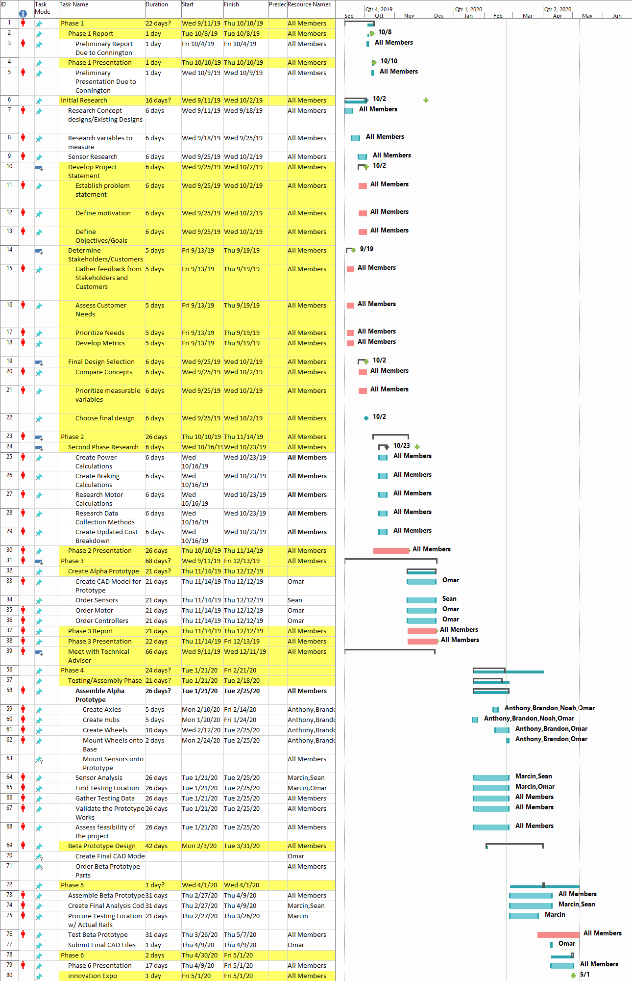

*Figure 19: Complete Gantt Chart*

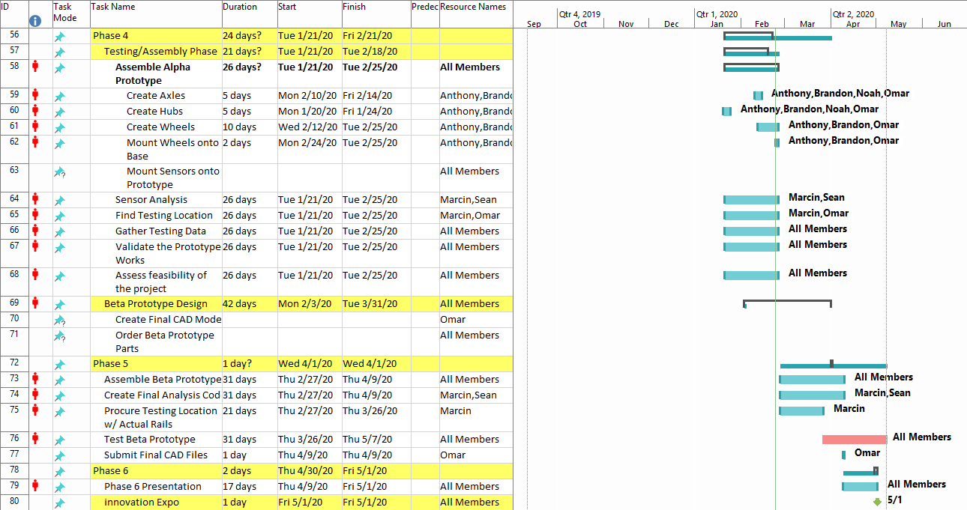

*Figure 20: Phase IV to Phase VI Plan*

The above Gantt Charts show the timeline for the project. Much of the time was allocated towards making the body of the prototype in the machine shop. The critical path and milestones are shown which indicates the steps the team took towards completing Phase IV. The dates and deliverables for Phase V are shown which dictate the course of action for the project. The beta prototype is the main priority with the machined parts from the alpha getting reused for the final prototype. Once the Beta prototype is assembled, the vehicle will be tested on actual tracks to confirm that the sensors and programs work as intended.

## References

1. Metropolitan Transportation Authority (2018). MTA annual subway ridership facts and figures.
2. Federal Railroad Administration (2017). Track and rail and infrastructure integrity compliance manual.
3. Magel, E. E. (2017). A Survey of Wheel/Rail Friction (OMB No. 0704-0188). Washington, DC: Office of Research, Development and Technology.
4. Backs, J.a.j., et al. “Warning Systems Triggered by Trains Could Reduce Collisions with Wildlife.” *Ecological Engineering*, vol. 106, 2017, pp. 563–569., doi:10.1016/j.ecoleng.2017.06.024.
5. de Vos, Paul. *Railway Induced Vibration - State of the Art Report*. UIC-ETF (Railway Technical Publications), Nov. 2017, uic.org/IMG/pdf/vibration_report_v2.pdf.
6. “Torsional and Axial Holding Power.” Eastern Creek, Australia, 22 Apr. 2016. <https://www.hobson.com.au/files/technical/utd-sg-i-hold-power.pdf>
7. Qijin Chen, Xiaoji Niu, Lili Zuo, Tisheng Zhang, Fuqin Xiao, Yi Liu and Jingnan Liu, *A Railway Track Geometry Measuring Trolley System Based on Aided INS*, Published in MDPI, Switzerland, 10 Feb 2018
8. Facts and Figures. Subway FAQ. <https://www.nycsubway.org/wiki/Subway_FAQ:_Facts_and_Figures>
9. The United States Department of Transportation’s Track Safety Standards Compliance Manual (2002)